<Software> on the AWS Cloud

Quick Start Reference Deployment

Month 2017

*<Partner Organization>*

*AWS Quick Start Reference Team*

Contents

Overview 2

<software> on AWS 2

Costs and Licenses 2

Architecture 2

Prerequisites 3

Specialized Knowledge 3

Technical Requirements 4

Deployment Options 4

Deployment Steps 4

Step 1. Prepare Your AWS Account 4

Step 2. Subscribe to the <software> AMI 4

Step 3. Launch the Quick Start 5

Step 4. Test the Deployment 8

Best Practices Using <software> on AWS 8

Security 8

<Other Useful Information> 9

FAQ 9

Additional Resources 10

Send Us Feedback 11

Document Revisions 11

This Quick Start deployment guide was created by Amazon Web Services (AWS) in partnership with *<partner organization>*.

[Quick Starts](http://aws.amazon.com/quickstart/) are automated reference deployments that use AWS CloudFormation templates to deploy key technologies on AWS, following AWS best practices.

## Overview

This Quick Start reference deployment guide provides step-by-step instructions for deploying <software> on the Amazon Web Services (AWS) Cloud.

This Quick Start is for users who… *(target audience).*

### <software> on AWS

*Brief description of software and its use. Include the benefits of using the software on AWS, and provide details on usage scenarios.*

### Costs and Licenses

You are responsible for the cost of the AWS services used while running this Quick Start reference deployment. There is no additional cost for using the Quick Start.

The AWS CloudFormation template for this Quick Start includes configuration parameters that you can customize. Some of these settings, such as instance type, will affect the cost of deployment. For cost estimates, see the pricing pages for each AWS service you will be using. Prices are subject to change.

*Provide information about licensing requirements for the product being deployed.*

## Architecture

Deploying this Quick Start for a new virtual private cloud (VPC) with **default parameters** builds the following <software> environment in the AWS Cloud.

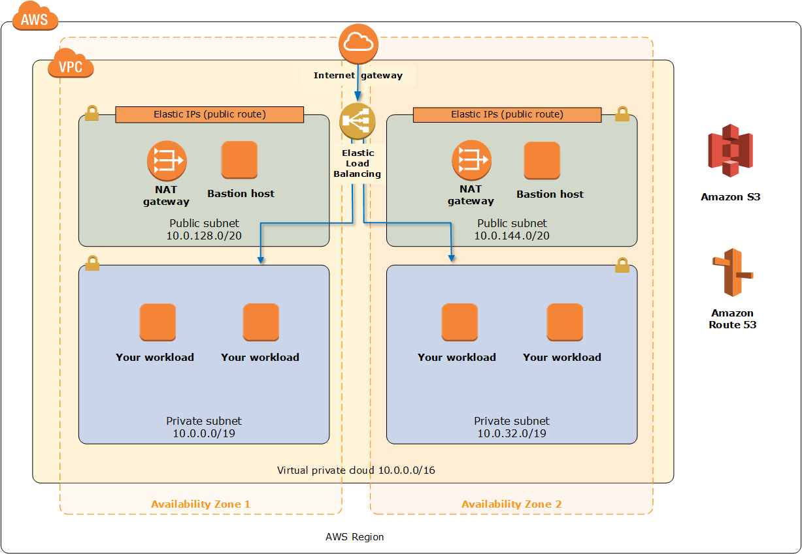

Figure 1: Quick Start *<software>* architecture on AWS

The Quick Start sets up the following:

*Provide a brief description of architectural components in a bulleted list.*

## Prerequisites

### Specialized Knowledge

Before you deploy this Quick Start, we recommend that you become familiar with the following AWS services. (If you are new to AWS, see [Getting Started with AWS](https://aws.amazon.com/getting-started/).)

* [Amazon VPC](https://aws.amazon.com/documentation/vpc/)
* [Amazon EC2](https://aws.amazon.com/documentation/ec2/)
* [Amazon EBS](https://docs.aws.amazon.com/AWSEC2/latest/UserGuide/AmazonEBS.html)
* *Links to other relevant AWS services, and other knowledge expectations*

### Technical Requirements

*AWS account configuration, operating system, licensing, DNS, etc. requirements*

## Deployment Options

This Quick Start provides two deployment options:

* **Deploy** <software> **into a new VPC** (end-to-end deployment). This option builds a new AWS environment consisting of the VPC, subnets, NAT gateways, security groups, bastion hosts, and other infrastructure components, and then deploys <software> into this new VPC.
* **Deploy** <software> **into an existing VPC**. This option provisions <software> in your existing AWS infrastructure.

The Quick Start provides separate templates for these options. It also lets you configure CIDR blocks, instance types, and <software> settings, as discussed later in this guide.

## Deployment Steps

### Step 1. Prepare Your AWS Account

1. If you don’t already have an AWS account, create one at <https://aws.amazon.com> by following the on-screen instructions.
2. Use the region selector in the navigation bar to choose the AWS Region where you want to deploy <software> on AWS.
3. Create a [key pair](https://docs.aws.amazon.com/AWSEC2/latest/UserGuide/ec2-key-pairs.html) in your preferred region.
4. If necessary, [request a service limit increase](https://console.aws.amazon.com/support/home#/case/create?issueType=service-limit-increase&limitType=service-code-) for the Amazon EC2 <type> instance type. You might need to do this if you already have an existing deployment that uses this instance type, and you think you might exceed the [default limit](http://docs.aws.amazon.com/AWSEC2/latest/UserGuide/ec2-resource-limits.html) with this reference deployment.

### Step 2. Subscribe to the <software> AMI

1. Log in to the AWS Marketplace at <https://aws.amazon.com/marketplace>.
2. Open the page for <software>, and choose **Continue**.
3. Use the **Manual Launch** option to launch the AMI into your account on Amazon EC2. This involves accepting the terms of the license agreement and receiving confirmation email. For detailed instructions, see the [AWS Marketplace documentation](https://aws.amazon.com/marketplace/help/200799470).

### Step 3. Launch the Quick Start

**Note** You are responsible for the cost of the AWS services used while running this Quick Start reference deployment. There is no additional cost for using this Quick Start. For full details, see the pricing pages for each AWS service you will be using in this Quick Start. Prices are subject to change.

1. Choose one of the following options to launch the AWS CloudFormation template into your AWS account. For help choosing an option, see deployment options earlier in this guide.

|  |  |
| --- | --- |
| Option 1  [**Launch**](https://console.aws.amazon.com/cloudformation/home?region=us-east-2#cstack=sn%7EOracle-Database%7Cturl%7Ehttps://s3.amazonaws.com/quickstart-reference/)  Deploy <software> into a  new VPC on AWS | Option 2  [**Launch**](https://console.aws.amazon.com/cloudformation/home?region=us-east-2#cstack=sn%7EOracle-Database%7Cturl%7Ehttps://s3.amazonaws.com/quickstart-reference/)  Deploy <software> into an existing VPC on AWS |

**Important** If you’re deploying <software> into an existing VPC, make sure that your VPC has two private subnets in different Availability Zones for the database instances. These subnets require [NAT gateways or NAT instances](http://docs.aws.amazon.com/AmazonVPC/latest/UserGuide/vpc-nat.html) in their route tables, to allow the instances to download packages and software without exposing them to the Internet. You’ll also need the domain name option configured in the DHCP options as explained in the [Amazon VPC documentation](http://docs.aws.amazon.com/AmazonVPC/latest/UserGuide/VPC_DHCP_Options.html). You’ll be prompted for your VPC settings when you launch the Quick Start.

Each deployment takes about <x> hours to complete.

1. Check the region that’s displayed in the upper-right corner of the navigation bar, and change it if necessary. This is where the network infrastructure for <software> will be built. The template is launched in the US East (Ohio) Region by default.
2. On the **Select Template** page, keep the default setting for the template URL, and then choose **Next**.
3. On the **Specify Details** page, change the stack name if needed. Review the parameters for the template. Provide values for the parameters that require input. For all other parameters, review the default settings and customize them as necessary. When you finish reviewing and customizing the parameters, choose **Next**.

In the following tables, parameters are listed by category and described separately for the two deployment options:

* Parameters for deploying <software> into a new VPC
* Parameters for deploying <software> into an existing VPC
* **Option 1: Parameters for deploying <software> into a new VPC**

[View template](https://s3.amazonaws.com/quickstart-reference/)

*<The following parameter tables are generated automatically from the templates. Don’t enter the parameter information manually. The information below is provided only as an example. We recommend that you use these group and parameter labels for similar functionality in your CloudFormation templates.>*

*VPC Network Configuration:*

|  |  |  |
| --- | --- | --- |
| Parameter label (name) | Default | Description |
| Availability Zones (AvailabilityZones) | *Requires input* | The list of Availability Zones to use for the subnets in the VPC. The Quick Start uses two Availability Zones from your list and preserves the logical order you specify. |
| VPC CIDR (VPCCIDR) | 10.0.0.0/16 | CIDR block for the VPC. |
| Private Subnet 1 CIDR (PrivateSubnet1CIDR) | 10.0.0.0/19 | CIDR block for the private subnet located in Availability Zone 1. |
| Private Subnet 2 CIDR (PrivateSubnet2CIDR) | 10.0.32.0/19 | CIDR block for the private subnet located in Availability Zone 2. |
| Public Subnet 1 CIDR (PublicSubnet1CIDR) | 10.0.128.0/20 | CIDR block for the public (DMZ) subnet located in Availability Zone 1. |
| Public Subnet 2 CIDR (PublicSubnet2CIDR) | 10.0.144.0/20 | CIDR block for the public (DMZ) subnet located in Availability Zone 2. |
| Permitted IP range (AccessCIDR) | *Requires input* | The CIDR IP range that is permitted to access <software>. We recommend that you set this value to a trusted IP range. For example, you might want to grant only your corporate network access to the software. |

*Amazon EC2 Configuration:*

|  |  |  |
| --- | --- | --- |
| Parameter label (name) | Default | Description |
| Key Name (KeyPairName) | *Requires input* | Public/private key pair, which allows you to connect securely to your instance after it launches. When you created an AWS account, this is the key pair you created in your preferred region. |
| NAT Instance Type (NATInstanceType) | t2.small | EC2 instance type for NAT instances. This parameter is used only if your selected AWS Region doesn’t support NAT gateways. |

*AWS Quick Start Configuration:*

|  |  |  |
| --- | --- | --- |
| Parameter label (name) | Default | Description |
| Quick Start S3 Bucket Name (QSS3BucketName) | quickstart-reference | S3 bucket where the Quick Start templates and scripts are installed. Use this parameter to specify the S3 bucket name you’ve created for your copy of Quick Start assets, if you decide to customize or extend the Quick Start for your own use. The bucket name can include numbers, lowercase letters, uppercase letters, and hyphens, but should not start or end with a hyphen. |
| Quick Start S3 Key Prefix (QSS3KeyPrefix) | atlassian/bitbucket/latest/ | The [S3 key name prefix](https://docs.aws.amazon.com/AmazonS3/latest/dev/UsingMetadata.html) used to simulate a folder for your copy of Quick Start assets, if you decide to customize or extend the Quick Start for your own use. This prefix can include numbers, lowercase letters, uppercase letters, hyphens, and forward slashes. |

* **Option 2: Parameters for deploying** <software> **into an existing VPC**

[View template](https://s3.amazonaws.com/quickstart-reference/)

*<The following parameter tables are generated automatically from the templates. Don’t enter the parameter information manually. The information below is provided only as an example. We recommend that you use these group and parameter labels for similar functionality in your CloudFormation templates.>*

*Network Configuration:*

|  |  |  |
| --- | --- | --- |
| Parameter label (name) | Default | Description |
| VPC ID (VPCID) | *Requires input* | ID of your existing VPC (e.g., vpc-0343606e). |
| Private Subnet 1 ID (PrivateSubnet1ID) | *Requires input* | ID of the private subnet in Availability Zone 1 in your existing VPC (e.g., subnet-a0246dcd). |
| Private Subnet 2 ID (PrivateSubnet2ID) | *Requires input* | ID of the private subnet in Availability Zone 2 in your existing VPC (e.g., subnet-b58c3d67). |
| Bastion Security  Group ID  (BastionSecurityGroupID) | *Requires input* | ID of the bastion security group in your existing VPC (e.g., sg-7f16e910). |

*Amazon EC2 Configuration:*

|  |  |  |
| --- | --- | --- |
| Parameter label (name) | Default | Description |
| Key Pair Name (KeyPairName) | *Requires input* | Public/private key pair, which allows you to connect securely to your instance after it launches. When you created an AWS account, this is the key pair you created in your preferred region. |

1. On the **Options** page, you can [specify tags](https://docs.aws.amazon.com/AWSCloudFormation/latest/UserGuide/aws-properties-resource-tags.html) (key-value pairs) for resources in your stack and [set advanced options](https://docs.aws.amazon.com/AWSCloudFormation/latest/UserGuide/cfn-console-add-tags.html). When you’re done, choose **Next**.
2. On the **Review** page, review and confirm the template settings. Under **Capabilities**, select the check box to acknowledge that the template will create IAM resources.
3. Choose **Create** to deploy the stack.
4. Monitor the status of the stack. When the status is **CREATE_COMPLETE**, the <software> cluster is ready.
5. Use the URLs displayed in the **Outputs** tab for the stack to view the resources that were created.

### Step 4. Test the Deployment

*Add steps as necessary for accessing the software, post-configuration, and testing.*

## Best Practices Using <software> on AWS

*Provide information about best practices for using the technology on AWS, including considerations such as migrating data, backups, ensuring high performance, high availability, etc. Link to software documentation for detailed information.*

## Security

*Discussion of security-related components, considerations, responsibilities, best practices.*

## <Other Useful Information>

*Provide any other information of interest to users, especially focusing on areas where AWS or cloud usage differs from on-premises usage.*

## FAQ

*Any tips or answers to anticipated questions. This could include the following troubleshooting information. If you don’t have any other Q&A to add, change this heading to “Troubleshooting” and remove the Q/A headings below.*

**Q.** I encountered a CREATE_FAILED error when I launched the Quick Start. What should I do?

**A.** If AWS CloudFormation fails to create the stack, we recommend that you relaunch the template with **Rollback on failure** set to **No**. (This setting is under **Advanced** in the AWS CloudFormation console, **Options** page.) With this setting, the stack’s state will be retained and the instance will be left running, so you can troubleshoot the issue. (You'll want to look at the log files in %ProgramFiles%\Amazon\EC2ConfigService and C:\cfn\log.)

**Important** When you set **Rollback on failure** to **No**, you’ll continue to incur AWS charges for this stack. Please make sure to delete the stack when you’ve finished troubleshooting.

For additional information, see [Troubleshooting AWS CloudFormation](https://docs.aws.amazon.com/AWSCloudFormation/latest/UserGuide/troubleshooting.html) on the AWS website or contact us on the [AWS Quick Start Discussion Forum](https://forums.aws.amazon.com/forum.jspa?forumID=178).

**Q.** I encountered a size limitation error when I deployed the AWS Cloudformation templates.

**A.** We recommend that you launch the Quick Start templates from the location we’ve provided or from another S3 bucket. If you deploy the templates from a local copy on your computer or from a non-S3 location, you might encounter template size limitations when you create the stack. For more information about AWS CloudFormation limits, see the [AWS documentation](http://docs.aws.amazon.com/AWSCloudFormation/latest/UserGuide/cloudformation-limits.html).

## Additional Resources

**AWS services**

* Amazon EC2  
  <https://docs.aws.amazon.com/AWSEC2/latest/WindowsGuide/>
* AWS CloudFormation  
  <https://aws.amazon.com/documentation/cloudformation/>
* Amazon VPC  
  <https://aws.amazon.com/documentation/vpc/>

***<Software>***

* *Useful links for the software being deployed, e.g., to documentation, videos, etc.*

**Quick Start reference deployments**

* AWS Quick Start home page  
  <https://aws.amazon.com/quickstart/>

## Send Us Feedback

You can visit our [GitHub repository](https://github.com/aws-quickstart/tbd) to download the templates and scripts for this Quick Start, to post your comments, and to share your customizations with others.

## Document Revisions

|  |  |  |
| --- | --- | --- |
| Date | Change | In sections |
| <month> 2017 | *Brief description of change. Formatting and minor text changes don’t warrant any mention; major additions and changes do.* | *Links to revised sections* |
| <month> 2017 | Initial publication | — |

© 2017, Amazon Web Services, Inc. or its affiliates, and <partner organization>. All rights reserved.

**Notices**

This document is provided for informational purposes only. It represents AWS’s current product offerings and practices as of the date of issue of this document, which are subject to change without notice. Customers are responsible for making their own independent assessment of the information in this document and any use of AWS’s products or services, each of which is provided “as is” without warranty of any kind, whether express or implied. This document does not create any warranties, representations, contractual commitments, conditions or assurances from AWS, its affiliates, suppliers or licensors. The responsibilities and liabilities of AWS to its customers are controlled by AWS agreements, and this document is not part of, nor does it modify, any agreement between AWS and its customers.

The software included with this paper is licensed under the Apache License, Version 2.0 (the "License"). You may not use this file except in compliance with the License. A copy of the License is located at <http://aws.amazon.com/apache2.0/> or in the "license" file accompanying this file. This code is distributed on an "AS IS" BASIS, WITHOUT WARRANTIES OR CONDITIONS OF ANY KIND, either express or implied. See the License for the specific language governing permissions and limitations under the License.